Software Engineering Project – COS 301

Ambitious Designs

Software User Manual



**Project Team:** Dian Veldsman –

**Project Manager:** Stephen Swanepoel – 11032091

**Project Owner:** Willem Burger

# Abstract

This document is the Software User Manual for Smart Image Identifier. The Software User Manual instructs how to install and use the Smart Image Identifier software.

This project is part of the Software Engineering course COS 301 at the University of Pretoria.

Contents

Abstract 2

Overview 4

Tutorial 5

Installing the Software 5

1.1. Install Eclipse 5

1.2. Importing the project 5

1.3. Setting system environment variables 5

# Overview

The software implements human detection within images. Images are retrieved from the server and processed by Smart Image Identifier which returns a Boolean response.

# Tutorial

## Installing the Software

* 1. Install Eclipse   
       
     The easiest way to build the dispatcher from source is using Eclipse Neon. Eclipse Neon is a development environment and is open-source software. The latest version of this software can be obtained at <https://www.eclipse.org/downloads/>. After the download is completed, install the software using the instructions provided by the installer.
  2. Importing the projectIn Eclipse, click *File* > *Import* > *General* > finally, select *Existing Projects into Workspace* and click *Next*.   
     *Select root directory* > click *browse* > locate the given project folder > finally, select *Finish*.
  3. Setting system environment variablesSetting of environment variables is necessary for your system to detect the OpenCV framework which was used for developing Smart Image Identifier.  
       
     Lets get started.  
       
     1. Step 1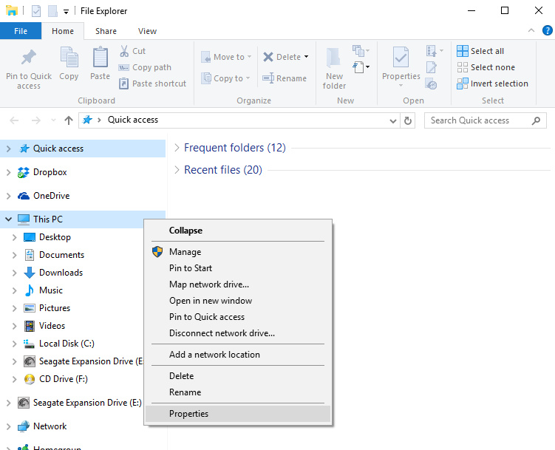  
        Open *File Explorer* > right click on *This PC* (Yours may be named otherwise) > click *Properties*
     2. Step 2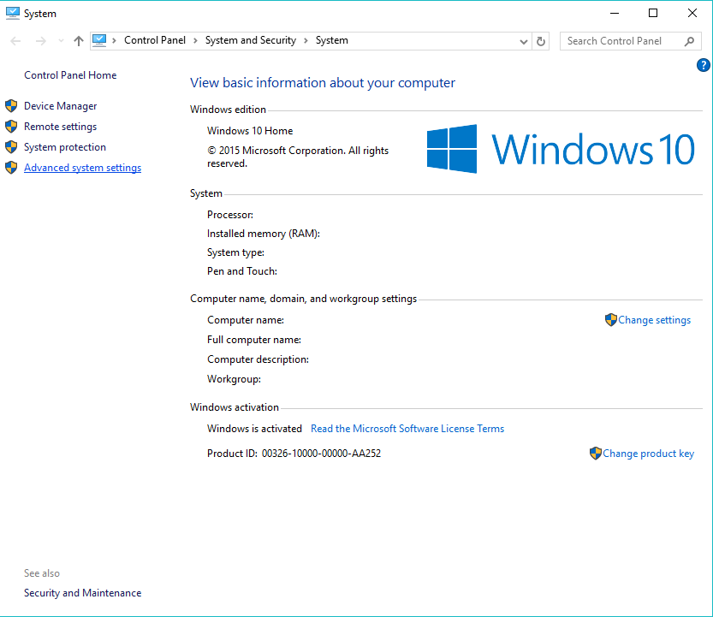  
        On the left hand panel select *Advanced System Settings*
     3. Step 3  
        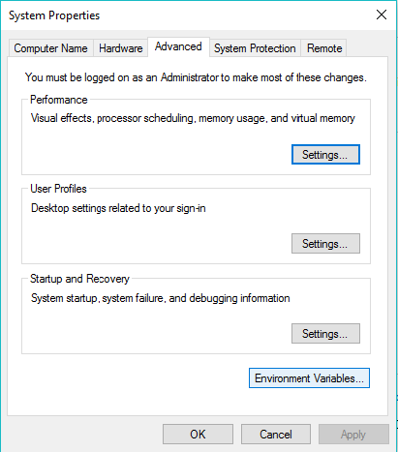  
        Click *Environment Variables* located at the bottom of the window
     4. Step 4  
        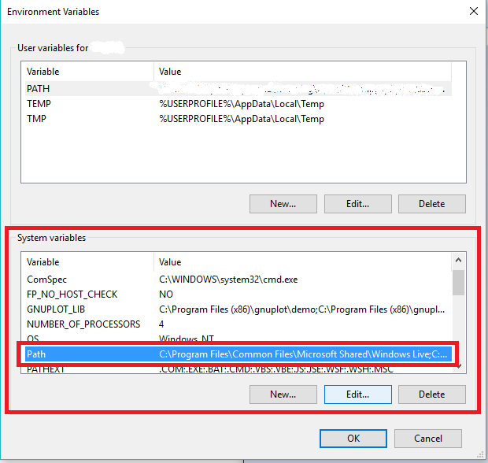  
        Select *Path* > click *Edit*
     5. Step 5  
        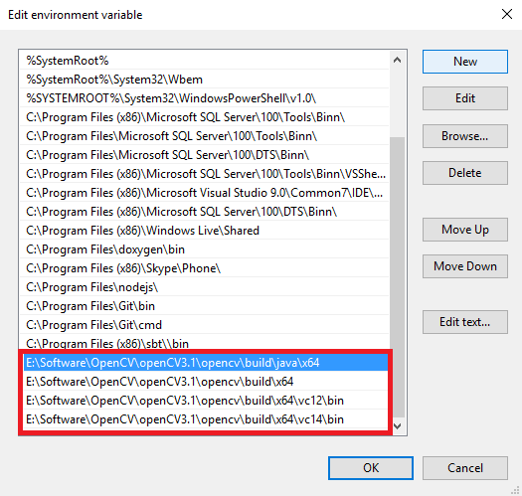  
        Select *New* > enter the paths to the above folders which may be located in the given OpenCV files > restart computer to take effect.